Promoting the education of orphans in the DRC by CONSORTIUM OF THE AFRICA GREAT LAKES REGION has just posted a report about the impact of your donations. You have made 23 donations for a total of $2,435.82 to this project. Your most recent donation to this project was last week. Here's the unedited update:

Second-quarter report Education project 2026
By Dieudonne Bisibo | Project Leader
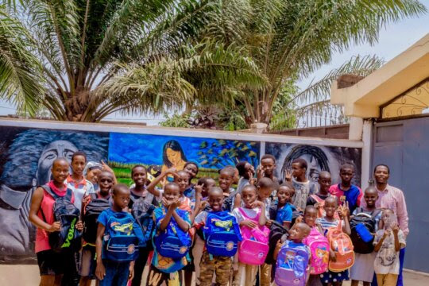
Photo of activity
Who are we?
The African Great Lakes Consortium is a union of 11 local non-profit organizations working in solidarity to support vulnerable victims of armed conflict and natural disasters. These organizations have taken the initiative to collaborate to contribute to the socio-economic recovery and self-care of vulnerable groups, including orphaned children and women survivors of sexual violence, widows, the disabled, refugees, displaced persons, and flood victims.
Created in Uvira in 2022 following a General Assembly of member non-governmental organizations, CONSORTIUM OF THE AFRICAN GREAT LAKES REGION “CORGLA”
Our mission is to contribute to the reconstruction of the broken hearts and lives of victims of armed conflicts in the African Great Lakes region by giving them hope to become themselves, capable of working to take care of themselves far from armed conflicts and violence.
Our vision is to live in a peaceful and prosperous Africa.
Our goal is to work in solidarity to support the vulnerable in the African Great Lakes Region (Burundi and DR Congo).
The Consortium's areas of intervention are: Peace and Conflict Resolution, Education, Health and Nutrition, Trauma Healing, Youth Promotion, Protection and Food Security.
Location of activities: African Great Lakes Region (DR Congo and Burundi)
Period: 4 months (from June to september 2026).
Table of contents:
- Education project
- Finance
- Recommendations

- Project to support education for vulnerable people
During this quarter, we provided financial support to cover the children’s school fees for the final term of the 2025–2026 academic year. In addition, we distributed school kits to the children to support their preparation for the new 2026–2027 academic year.
The children demonstrated encouraging academic performance throughout the year. 85% of the children completed the school year with satisfactory results, while 15% achieved distinction-level results. We are pleased to report that no school failures were recorded during the 2025–2026 academic year.
These results reflect the children’s commitment to their education, as well as the continued support provided by the program. The school kits distributed for the new academic year will help ensure that the children have the basic materials they need to begin their studies in good conditions.
Support for the administration
We supported our field teams with internet connection and supervision costs
- Finance:
Source of funds: GlobalGiving and donation
Total donations: 725.5 USD
Spent :
Projects 95%
Administration and logistics 5%
- Recommendations
Share this report with like-minded international organizations that may be interested in joining the consortium.
Share the report with potential donors who might be attracted by our activities and support us.
Anyone who expresses an interest in supporting us, making a donation or funding one of our projects can contact us at the following addresses: http://www.copgla.org/
Make a donation: http://goto.gg/67043
Links:
- Consortium website link
Attachments:
- Education project report (PDF)

On a scale of 0 to 10, how likely are you to recommend this project to a friend, family member, or colleague?
0 | 1 | 2 | 3 | 4 | 5 | 6 | 7 | 8 | 9 | 10
  Not at all likely |  | Extremely likely

GIVE NOW

Updates are posted directly by Project Leaders, and to make your experience as authentic as possible, GlobalGiving does not alter these updates - they are the real deal.
About this project:
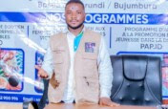 | Promoting the education of orphans in the DRC  by CONSORTIUM OF THE AFRICA GREAT LAKES REGION  Congo, Democratic Republic of the, Education  Everyone knows that every child has the right to an education, but the thousands of orphaned children in the Democratic Republic of Congo (DRC) often find themselves without assistance, risking their lives and losing all hope for the future. In developing this project, we are determined to provide school equipment, food, school transport and free education to 150 orphaned students in the DRC. We are determined to support these children and offer them a better future.

update email preferences - unsubscribe - privacy policy
GlobalGiving - 1 Thomas Circle NW, Suite 800, Washington, DC 20005, USA
GlobalGiving UK - Office 605, Albert House, 256-260 Old St, London EC1V 9DD, UK
Contact Us
GlobalGiving

